
New World Industries Inc.

RF-500/550-1 thru –8 Wireless Controller

The RF-500/550 wireless controller is a compact unit with two parts. One part is the base unit and the other piece is the keyfob actuator. Base units are available with 1,2,3,4,5,6,7 and 8 DC outputs that can be used to trigger the I/O’s on all of NWI’s standard line of controllers, valve coils, solenoids or PLC inputs. The keyfob/8 button is used to transmit a corresponding signal to the base unit (receiver) to act as a remote switching device.
Depending on the number of remotely activated outputs, that number is reflected in the dash # suffix of the model, i.e. a RF-500/550-2 would be a 2 output base unit with a 2-button keyfob and so on.

Set-up and Operation

All RF-500/550 controllers come factory un-programmed. That means matching the base unit (receiver) to the keyfob/8 button is done by the end-user. This gives a matched (1 of 16 million combinations @ 418MHz) interface between the keyfob and base unit. See Figure 1 for keyfob button assignments. 8 Button transmitters are numbered.

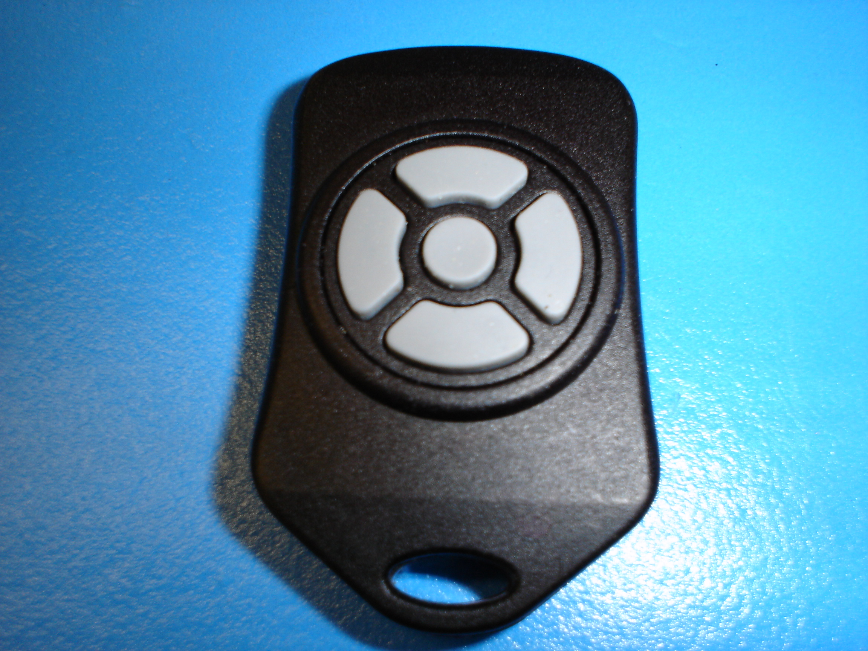
S4
S3
S5
S1
S2

Fig. 1 Keyfob Button Assignments
The RF-500 comes in different configurations. Shown above is the 5 output example (i.e. RF-500-5). This is the maximum controlled output using a keyfob. As the number of available outputs decrease so will the amount of buttons on the keyfob. The button # assignments are always in the same place. They decrease in this order:

- 4 Button keyfob will be minus S5 button/ RF-500-4
- 3 Button keyfob will be minus S1 and S3/ RF-500-3
- 2 Button keyfob will be minus S1, S3 and S5/ RF-500-2
- 1 Button keyfob will be minus S1, S2, S3 and S4/ RF-500-1

Fig. 2 is the receiver or base unit. This picture shows the terminal designations and other functions. On receivers with flying lead connections see installation manual.
6VDC-
28VDC
GRD
PWR
Grn LED
S1 output

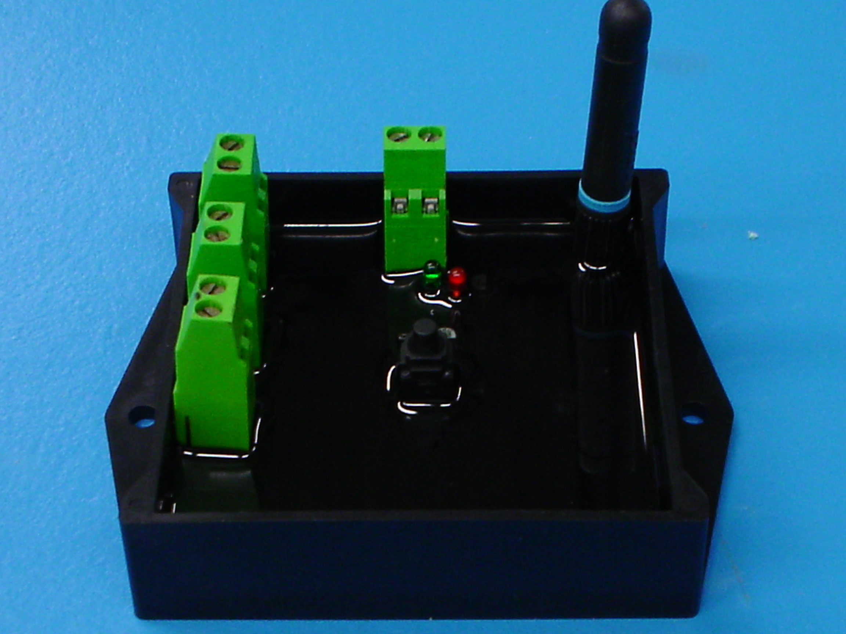
Antenna
Receiver
Programming
Red LED
Learn
Address
Button
S2 output
S3 output
S4 output
S5 output

Fig. 2 Receiver Connection diagram and layout for a screw terminal open-faced enclosure.

Set-up of Keyfob/8 button to Receiver Address

The next step to the RF-500/550 installation is to create a 1 in 16 million address between the keyfob and the base unit.

Please follow these steps:

- Power-up the RF-500/550 receiver.
- On the backside of the keyfob or 8 button, depress the “ADD” button using a paperclip and until the blue LED starts to flash (if working properly a blue light in the window will blink for 15 seconds).
- Flip keyfob/8 button over and push each button individually to create a transmitter address within 15 seconds.
- After the blue LED stops flashing (15 seconds) go to the receiver box and push the black program button. The red LED will begin to flash.
- Again, push each button on the keyfob/8 button to save that unique transmitter address to the receiver. Up to 40 transmitters can be programmed to one receiver.
- Push black button on the receiver box to end programming mode and the red LED will stop flashing or it will automatically turn off after 15 seconds.

Your RF-500/550 is now ready to use.

Battery Replacement

The keyfob uses a standard CR2032 lithium button cell battery. In normal use it will provide 1 to 2 years of operation. To replace the battery, gently pry apart the 2 halves on the keyfob or remove battery cover on the 8 button transmitter. Remove the battery by sliding it out from underneath the retainer. Observe the battery polarity when replacing. Once the battery is replaced, repeat the previous paragraphs steps to set a new address.

Other Considerations
Only one transmitter at a time can be activated within a reception area. Only one carrier of a particular frequency may occupy the same airspace at a given time. This means that if two transmitters are activated in the same area at the same time the signals will interfere and the decoder on the receiver will not see a valid transmission and the RF-500/550 will not function properly.

For further technical assistance please contact New World Industries Inc.

Copyright, New World Industries Inc., 2006

